**FIND YOUR DESTINAION**

**BACHELOR OF TECHNOLOGY**

**IN**

**COMPUTER SCIENCE AND ENGINEERING**

**BY**

**N. Akhila 21501A05C8**

**M. Raja Nandini 21501A05A4**

**K. Pujitha 21501A0573**

**Under the Guidance of**

**Mrs. D. SREE LAKSHMI (Ph.D.)**

**Assistant Professor**

**&**

**Ms. K. JYOTSHNA DVEI (M.Tech,Ph.D.)**

**Assistant Professor**



**PRASAD V POTLURI SIDDHARTHA INSTITUTE OF TECHNOLOGY**

(Permanently affiliated to JNTU :: Kakinada, Approved by AICTE)

(An NBA & NAAC accredited and ISO 9001:2008 certified institution)

**Kanuru, Vijayawada - 520007**

**(2023-2024)**

**PRASAD V POTLURI**

SIDDHARTHA INSTITUTE OF TECHNOLOGY

(Permanently affiliated to JNTU :: Kakinada, Approved by AICTE)

(An NBA & NAAC accredited and ISO 9001:2008 certified institution)

**Kanuru, Vijayawada – 520007**



**CERTIFICATE**

This is to certify that the project report title **“ FIND YOUR DESTINAON”**is the bonafied work of **Akhila (21501a05c8), Raja Nandini (21501a05a4), Pujitha (21501a0573)** in partial fulfillment of completing the Academic project in Web Application Development during the academic year 2023-2024.

**Signature of the Incharge Signature of the HOD**

**Mrs. D. SREE LAKSHMI Dr. A. Jayalakshmi**

Asst. Professor, CSE Dept. Head, Department of CSE

**INDEX**

|  |  |  |
| --- | --- | --- |
| **S.No.** | **Content** | **Page No. (s)** |
| 1 | Abstract |  |
| 2 | Introduction |  |
| 3 | Objectives and Scope of the Project |  |
| 4 | Software used - Explanation |  |
| 5 | Back End if Existing |  |
| 6 | Web Pages (with explanation) |  |
| 7 | Sample Code |  |
| 8 | Result/Output Screen shots |  |
| 9 | Conclusion |  |
| 10 | References (web site URLs) |  |

# **ABSTRACT**

The evolution of the internet has transformed the way we plan and book our travels, with a myriad of online platforms vying for our attention. Among these, websites like Find your destination have carved a niche as powerful tools in the hands of travelers, providing an extensive database of accommodations and an array of features to streamline the booking process. This abstract delves into the core functionality, features, and impact of such websites, highlighting the role they play in redefining travel experiences in the digital age.

In the digital era, travel enthusiasts have witnessed a paradigm shift in the way they plan and book their journeys. Gone are the days of relying solely on travel agents or booking directly through hotels; instead, websites like this have emerged as comprehensive travel companions. These platforms serve as metasearch engines, aggregating data from a multitude of accommodation providers to offer users a one-stop destination for comparing prices, amenities, and availability.

The core functionality of a website revolves around its ability to simplify the travel booking process. This process involves web scraping and APIs to fetch real-time data from hotels, hostels, vacation rentals, and other lodging options

In this project, we are creating a Find your stay website using HTML, CSS, which is static and versatile web tool. This application allows users to get information about the places where you want to stay like 5 star hotels etc. The HTML structure forms the backbone of the website, offering input fields for user data and options to select the data type. CSS styling enhances the user interface, making it visually appealing and user-friendly. User interaction is key; the website offers real-time feedback and enables users to know the Best staying hotels. Additionally ,it provides the food provided in that particular Hotel.

In summary, this HTML, CSS -based Find your stay website is a user-friendly, all-in-one solution to Find your staying , catering to a wide range of user needs, from giving information to providing contact details. Real user reviews provide insights into the pros and cons of each accommodation, aiding travelers in making informed decisions.This website offer customer support services, ensuring that users have assistance in case of any issues with their bookings.

These platforms put the power in the hands of travelers, enabling them to make well-informed decisions, compare options, and ultimately get more value for their money.

The fierce competition among accommodation providers to be featured on these platforms often leads to competitive pricing, benefiting consumers.These websites simplify the booking process, eliminating the need to visit multiple websites or make numerous phone calls to book accommodations.Smaller and boutique accommodation options that might not have the marketing reach of larger chains can gain visibility and attract a broader customer base through these platforms.

**INTRODUCTION**

A Find your stay website is a platform where individuals can find their Best stay hotels . This website is dedicated to Travellers ,Job holders etc, offering a platform for Travellers to explore, and to make their stay happy. The website serves as a vibrant community connecting individuals passionate about travelling. This online platform serves as a hub for all travelling lovers to find good stay .

The purpose of a Find your Stay website is to provide a clear and best staying hotels to find their unique hotel and connect with its benefits provided in it. These websites typically include detailed descriptions and high-quality images of each hotel, allowing users to browse and get an idea about hotel in that site.

Many staying websites also offer additional features such as customer reviews, artist profiles, and a blog section to provide inspiration and guidance for other Travellers . These websites may also facilitate communication between sellers and buyers through messaging systems and offer contact options. As a hotelier or host, a hotel website is no more a nice to have. As a result of its several important functions, it has become a very useful tool that all hotels must have.In this website, using HTML and CSS we will design a homepage for our website. The homepage(index.html) welcomes users with a clean and inviting design with a navigation menu that contains home, contact us, blogs ,hotels, packages up.

Find your destination is not just another website; it is your ticket to a world of wanderlust, designed to make your travel dreams come true. Just like the name suggests, it's a platform that not only encourages your curiosity but also helps you navigate the vast realm of travel options effortlessly.

As avid travelers ourselves, we understand the excitement, the thrill, and the occasional uncertainty that accompanies planning a vacation. Whether you're a globetrotting enthusiast or a first-time explorer, this will is your trusty companion. We are dedicated to simplifying the complexities of travel, ensuring that every journey you embark upon is a memorable one.Overall, Find your saty websites offer a convenient and accessible way for travellers to find their unique hotel to stay with the cost provided based on the number of days they want to stay.

# **OBJECTIVES AND SCOPE OF THE PROJECT**

**Objectives:**

The primary objectives of this project revolve around the Travellers who wants to stay in a best and relevant priced. Its main purpose is to empower users to effortlessly find the best stay. In pursuit of user-friendliness, the project strives to offer an intuitive interface that minimizes technical barriers, ensuring that users can swiftly and easily get information about the best hotels in that location.

The website has several functional features. Visitors can check out all the suites and restaurants at the hotel in advance, see what they look like and what they serve. They can also check availability of their favorite suites and then go ahead to book them, all on the website.

Furthermore, This website is a convenient and user-friendly online place. It can support job holders as well to find a good hotel to stay. It also provide. This website shows offers provided by that hotel.

**Scope of the project:**

The scope of Find your stay website can vary depending on the specific goals and niche of the website. However, some common features and areas of focus include:

1. Finding Stay : The primary purpose of the website is to show the best hotels in that location.
2. Blog or inspiration section: Many staying websites also have a blog or inspiration section where they can share experience. This can attract more visitors and establish the website as a valuable resource for travelling enthusiasts.

1. Social media integration: Integrating social media platforms can help increase the reach of the website and attract potential customers. This may include links to the website's social media profiles, sharing buttons for individual products or blog posts, or embedding social media feeds on the website.

1. Customer support and contact information: It is essential to provide clear contact information and options for customer support, such as email, phone, or live chat. This builds trust and allows customers to reach out if they have any queries or issues.

Overall, the scope of a homemade crafts website can encompass various features, depending on the goals and target audience of the website owner.

**SOFTWARE USED**

**HTML**

HTML, which stands for HyperText Markup Language, is a standard markup language used for creating and structuring the content of web pages. It provides a set of elements and tags that define the structure, layout, and functionality of a webpage. HTML files can be viewed and interacted with on web browsers such as Chrome, Firefox, and Safari.HTML can be used to create simple static web pages, as well as more complex dynamic pages when combined with CSS (Cascading Style Sheets) and JavaScript, allowing for enhanced visual design and interactivity. CSS is used to control the appearance and layout of HTML content, while JavaScript adds functionality and interactivity to webpages.

# **CSS**

CSS, short for Cascading Style Sheets, is a stylesheet language used to control the presentation of a webpage. It is responsible for determining how elements on a webpage should be displayed and styled, including their color, size, position, and more. CSS works by targeting specific HTML elements and applying styles to them through a set of rules and selectors. It also enables web developers to create coherent and visually appealing designs that are consistent across different browsers and devices. With CSS, designers can create responsive layouts that adapt to different screen sizes and orientations, enhancing the user experience. Overall, CSS plays a crucial role in creating the visual aesthetics of a website and is a fundamental tool for web development.

# **Text editors**

Text editors are software tools used to write and edit code. As a student you may use a simple text editor like visual studio code.

Visual Studio, developed by Microsoft, stands as a robust integrated development environment (IDE) renowned for its pivotal role in software development. This versatile application encompasses the full spectrum of software development activities, including coding, debugging, and deployment. A distinguishing feature of Visual Studio is its remarkable support for core web development technologies, such as HTML, CSS, and JavaScript. With features like code completion, syntax highlighting, and live previews, it empowers developers to craft clean and error-free web code efficiently.

The IDE's compatibility with renowned front-end frameworks, including React, Angular, and Vue.js, is noteworthy. It incorporates project templates, extensions, and specialized tools that streamline development. Additionally, Visual Studio's intelligent code assistance, encompassing features like code completion, refactoring, error checking, and debugging tools, elevates code quality and developer productivity.

For developers, debugging web applications is a critical task, and Visual Studio excels in this domain. Its integrated debugger permits the setting of breakpoints, variable inspection, and code stepping, facilitating issue identification and resolution in both server-side and client-side code.

Furthermore, Visual Studio equips developers with tools for publishing web applications to web servers or cloud platforms. This simplifies packaging and deployment processes, enabling the seamless launch of web applications on diverse hosting services. Additionally, the IDE ensures cross-browser compatibility by offering the capability to test web pages across various browsers, guaranteeing that websites function optimally across diverse browser and platform environments. In summary, Visual Studio emerges as a comprehensive and indispensable tool for web development, replete with features tailored to simplify and enhance the development process.

**ABOUT WEB PAGES**

The home page of a Home Made Crafts website typically consists of various sections and fields aimed at providing users with easy navigation and access to different features. Let’s go through each of the fields mentioned:

**1.Home:**

This is often the default or landing page of the website. It serves as a starting point for users and often includes a brief description or introduction of the Home made Crafts service.

**2.Categories:**

The categories page contains two fields Toys and Decorations .By selecting the toys you can land on the toys page and can see different forms of toys. By selecting the Decorations page we can land on the decorations page and see the different forms of decorations.

**3. Contact:**

The Contact field allows users to easily get in touch with the website’s support or customer service team. It typically includes a contact form or an email address where users can send their queries, feedback, or even report any issues they encounter while using the generator.

**Categories page:**

A category Page is a webpage on a website that contains two categories toys and decoration by selecting the toys you can find different hand made toys such as konadapalli toys, clay toys, paper toys and hand knitted toys. Beside the image you can find the information about that toy .By selecting the decorations you find different decoration items which can be prepared at home. Beside the image you can find the information about that decoration item.By clicking on the images you can find a video about the making process of that.

**Contact Page:**

A contact page is a web page on a website that provides users with a way to get in touch with the website’s administrators, owners, or customer support team. It typically includes a form that allows users to submit their inquiries, feedback, or messages directly through the website.

The main purpose of a contact page is to offer an easy and convenient way for visitors to connect with the website,s team. It serves as a means of communication and helps establish a connection between the website and its users. This page is particularly important for businesses, organizations, or e-commerce websites that require user interaction and customer support.

Key components of a contact page may include:

1. **Contact Form:**

A contact form is the most essential element of a contact page. This form usually includes fields for the user to enter their name, email address, subject of their message, and a message box to write their query or feedback. Some contact forms may also include additional fields such as phone number, address, or specific dropdown options for inquiries.

1. **Contact Information**:

Alongside the contact form, the contact page often provides the website,s contact information such as email address, phone number, and physical address.This allows users to choose their preferred method of communication and get in touch directly if they do not wish to use the contact form.

It is important to ensure that the contact page is easily accessible and visible on a website, usually placed in the main navigation menu and/or footer section.

Additionally, the design and layout should be user-friendly, with clear instructions for filling out the contact form and submitting messages.A well-designed and functional contact page can contribute to a positive user experience, build trust with the website’s visitors, and facilitate effective communication between thewebsite and its users.

**Login or Signup page:**

A login page is a web page where users can enter their credentials, such as username and password, to access a restricted area of a website or application. This page usually consists of input fields for the user to enter their login information. On the other hand, a sign up page is a web page where new users can create an account on a website or application. This page typically requires users to provide certain personal information, including a unique username, email address, and a secure password. The sign-up page usually includes input fields for the necessary information, alongside buttons to submit the data or navigate back to the login page. Additionally, some sign-up pages may include additional optional fields like name, profile picture, or date of birth, depending on the platform or website’s requirements.

Both the login and sign-up pages aim to provide users with access to restricted content or personalized experiences on a website or application. The design and functionality of these pages may vary depending on the platform’s branding and user

experience principles but generally prioritize user-friendly interfaces, clear instructions, and robust security measures to protect user data.

**SAMPLE CODE**

# **Homepage code(index.html)**

<!DOCTYPE html>

<html lang="en">

<head>

<meta charset="UTF-8" />

<meta http-equiv="X-UA-Compatible" content="IE=edge" />

<meta name="viewport" content="width=device-width, initial-scale=1.0" />

<link rel="stylesheet" href="brochure.css" />

<title>FIND YOUR STAY</title>

</head>

<body>

<body>

<!--===========Nav Bar=================-->

<section class="nav-bar">

<div class="logo">FIND YOUR STAY</div>

<ul class="menu">

<li><a href="#">home</a></li>

<li><a href="restaurant.html">Restaurant</a></li>

<li><a href="packages.html">Package</a></li>

<li><a href="blog.html">Blog</a></li>

<li><a href="contact.html">Contact Us</a></li>

</ul>

</div>

</section>

<!--===============Banner================-->

<section class="banner">

<div class="banner-text-item">

<div class="banner-heading">

<h1>Find Your Stay</h1>

</div>

</section>

<!--=========Services===============-->

<section class="services">

<div class="service-item">

<img src="https://res.cloudinary.com/dxssqb6l8/image/upload/v1605293634/tour-guide_onzla9.png">

<h2>24 hours service</h2>

<li><a href="service.html">Service</a></li>

</div>

<div class="service-item">

<img src="https://res.cloudinary.com/dxssqb6l8/image/upload/v1605293738/reliability_jbpn4g.png">

<h2>Secure information</h2>

<li><a href="blog.html">Info</a></li>

</div>

<div class="service-item">

<img src="https://res.cloudinary.com/dxssqb6l8/image/upload/v1605293635/experience_a3fduk.png">

<h2>certified restaurants</h2>

</div>

<div class="service-item">

<img src="https://res.cloudinary.com/dxssqb6l8/image/upload/v1605293634/feedback_s8z7d9.png">

<h2>reviews</h2>

<li><a href="review.html">Reviews</a></li>

</div>

</section>

<!--==============Places===================-->

<section class="places">

<div class="places-text">

<small>FEATURED DESTINATIONS TO VISIT</small>

<h2>Favourite Places</h2>

</div>

<div class="cards">

<div class="card">

<div class="zoom-img">

<div class="img-card">

<img

src="https://r1imghtlak.mmtcdn.com/c944c56c2d2e11eaa2720242ac110003.jpg">

</div>

</div>

<div class="text">

<span class="rating">⭐⭐⭐⭐⭐</span>

<h2>Taj Tirupati</h2>

<p class="cost"> Rs. 3820/- / Per Person</p>

<div class="card-box">

<p class="time">🕓 1 Day</p>

<p class="location">✈ Tirupati, Andhra pradesh</p>

</div>

</div>

</div>

<div class="card">

<div class="zoom-img">

<div class="img-card">

<img src="https://r1imghtlak.mmtcdn.com/fa2af7e4d2cc11e9b0dc0242ac110002.jpg">

</div>

</div>

<div class="text">

<span class="rating">⭐⭐⭐⭐⭐</span>

<h2>Vivanta</h2>

<p class="cost">Rs. 1000/- Per Person</p>

<div class="card-box">

<p class="time">🕓 1 Day</p>

<p class="location">✈ Vijayawada, Andhra Pradesh</p>

</div>

</div>

</div>

<div class="card">

<div class="zoom-img">

<div class="img-card">

<img src="https://www.hotelatithiaurangabad.com/images/IMG_2777.jpg">

</div>

</div>

<div class="text">

<span class="rating">⭐⭐⭐⭐⭐</span>

<h2>Hotel Athithi Inn</h2>

<p class="cost">Rs. 2318 /- Per Person</p>

<div class="card-box">

<p class="time">🕓 1 Day</p>

<p class="location">✈ Machilipatnam, Andhra Pradesh</p>

</div>

</div>

</div>

<div class="card">

<div class="zoom-img">

<div class="img-card">

<img

src="https://cdn1.goibibo.com/voy_ing/t_g/5706b5223ac111eb89f00242ac110004.jpeg">

</div>

</div>

<div class="text">

<span class="rating">⭐⭐⭐⭐⭐</span>

<h2>Hotel Prime Land</h2>

<p class="cost">Rs. 1855 /- Per Person</p>

<div class="card-box">

<p class="time">🕓 1 Day</p>

<p class="location">✈ Kurnool , andhra Pradesh</p>

</div>

</div>

</div>

<div class="card">

<div class="zoom-img">

<div class="img-card">

<img src="https://theprimepark.com/wp-content/uploads/2019/11/ANH01.jpg">

</div>

</div>

<div class="text">

<span class="rating">⭐⭐⭐⭐⭐</span>

<h2>The Prime Park</h2>

<p class="cost">Rs. 1870/- / Per Person</p>

<div class="card-box">

<p class="time">🕓 1 Day</p>

<p class="location">✈ Amaravati, Andhra Pradesh</p>

</div>

</div>

</div>

<div class="card">

<div class="zoom-img">

<div class="img-card">

<img

src="https://images.trvl-media.com/hotels/9000000/8400000/8397800/8397735/6a29df64_z.jpg">

</div>

</div>

<div class="text">

<span class="rating">⭐⭐⭐⭐⭐</span>

<h2>Dolphin Hotel</h2>

<p class="cost">Rs. 2540/- / Per Person</p>

<div class="card-box">

<p class="time">🕓 1 Day</p>

<p class="location">✈ Machilipatnam, Andhra Pradesh</p>

</div>

</div>

</div>

</div>

</section>

<!--===========About Us===============-->

<section class="about">

<div class="about-img">

<img src="https://www.anttelecom.co.uk/hs-fs/hubfs/Depositphotos_57494311_xl-2015.jpg?width=1500&name=Depositphotos_57494311_xl-2015.jpg">

</div>

<div class="about-text">

<small>ABOUT OUR WEBSITE</small>

<h2>We are Explore Destination Website</h2>

<p>We intend to provide you the best experience of living and enjoying in a unknown place. Ther are all certain precautions been taken to provide you with the best searches of hotels to stay. We maintain transparent information with the client that helps to understand and trust us easily. We ensure you a safe trip with our booking where there would be no inconvineinces during the stay.</p>

</div>

</section>

<!--===========Contact us===============-->

<section class="CONTACT US">

<div class= "contact-link"

<link rel="info" href="contact.html">

</div>

</section>

<!--===========Footer=================-->

<div class="footer">

<div class="links">

<h3>Quick Links</h3>

<ul>

<li><a href="offer.html">Offers & Discounts</a></li>

<li><a href="contact.html">Contact Us</a></li>

<li><a href="about.html">About Us</a></li>

</ul>

</div>

</div>

</body>

</html>

</body>

**CSS code for main page:**

@import url("https://fonts.googleapis.com/css2?family=Barlow+Condensed:wght@500&display=swap");

@import url("https://fonts.googleapis.com/css2?family=Satisfy&display=swap");

@import url("https://fonts.googleapis.com/css2?family=Roboto:wght@300&display=swap");

* {

box-sizing: border-box;

margin: 0;

}

body,

html {

margin: 0;

padding: 0;

}

/*------------------------Scroll Bar-----------------------*/

::-webkit-scrollbar {

width: 20px;

}

::-webkit-scrollbar-track {

box-shadow: inset 0 0 5px grey;

border-radius: 10px;

}

::-webkit-scrollbar-thumb {

background-color: #fde65e;

border-radius: 10px;

}

::-webkit-scrollbar-thumb:hover {

background-color: #fde02f;

}

/*========================Nav Bar=========================*/

.nav-bar {

display: flex;

flex-flow: row wrap;

width: 100%;

height: 90px;

background-color: #fff;

box-shadow: 3px 3px 10px lightslategray;

align-items: center;

justify-content: center;

position: sticky;

top: 0;

z-index: 1;

}

.logo {

flex: 1;

font-size: 40px;

padding: 20px;

margin-left: 50px;

font-family: Satisfy;

}

ul.menu {

flex: 1;

display: flex;

flex-flow: row wrap;

}

.menu li {

flex: 1;

list-style-type: none;

font-size: 16px;

font-family: "Barlow Condensed";

text-align: center;

}

.menu li a {

text-decoration: none;

color: #000;

text-transform: uppercase;

}

.menu li a:hover {

color: midnightblue;

text-decoration: underline;

}

/*=============================Banner=============================*/

.banner {

background-image: url("https://cdn.addresshotels.com/wp-content/uploads/2020/10/the-lounge-hero-banner-1920x970-1-1536x776.jpg");

background-size: cover;

background-repeat: no-repeat;

background-position: center;

/*overflow: hidden;*/

width: 100%;

height: 100vh;

text-align: center;

position: relative;

display: flex;

justify-content: center;

align-items: center;

}

.banner::before {

content: "";

position: absolute;

display: block;

top: 0;

left: 0;

bottom: 0;

right: 0;

background-color: rgba(0, 0, 0, 0.2);

/*background-size: 100%;*/

}

.banner-text-item {

position: absolute;

width: 100%;

text-align: center;

display: flex;

flex-flow: column wrap;

justify-content: center;

align-items: center;

}

.banner-heading {

flex: 1;

}

.banner-heading h1 {

font-size: 100px;

font-weight: normal;

color: #fde02f;

font-family: Satisfy;

}

.banner-text-item .form {

flex: 1;

display: flex;

flex-flow: row wrap;

justify-content: center;

align-items: center;

background-color: rgba(255, 255, 255, 0.2);

border-radius: 5px;

width: 70%;

padding: 1% 2%;

}

.banner-text-item input,

.banner-text-item .date,

.banner-text-item .book {

padding: 15px;

margin-right: 10px;

font-size: 18px;

font-family: Roboto;

border-radius: 5px;

outline: 0;

border: none;

}

.banner-text-item input {

width: 50%;

flex: 2;

}

.banner-text-item .date {

width: 20%;

flex: 1;

}

.banner-text-item .book {

width: 20%;

flex: 1;

}

.banner-text-item .book {

text-decoration: none;

color: #000;

text-transform: uppercase;

padding: 15px;

cursor: pointer;

background-color: #fde02f;

font-size: 16px;

font-weight: normal;

font-family: "Barlow Condensed";

width: 20%;

}

/*===========================Services===========================*/

.services {

display: flex;

flex-flow: row;

align-items: center;

justify-content: center;

}

.service-item {

flex: 1;

padding: 50px 10px;

border: lightcyan solid 1px;

text-align: center;

margin: 180px 50px;

transition: all 1s;

display: flex;

flex-flow: column;

align-items: center;

justify-content: center;

}

.service-item:hover {

box-shadow: 3px 3px 20px lightsteelblue;

}

.service-item h2 {

font-family: "Consolas", monospace;

font-size: 24px;

width: 120px;

color: #001f38;

flex: 1;

}

.service-item img {

width: 60px;

height: 60px;

flex: 1;

}

/*=============================Places===============================*/

.places-text {

text-align: center;

margin-bottom: 50px;

}

.places-text small {

font-family: Roboto;

color: #ffc342;

font-size: 15px;

font-weight: bolder;

}

.places-text h2 {

font-family: Barlow Condensed;

font-size: 55px;

color: #191d34;

letter-spacing: 1px;

}

.cards {

display: grid;

grid-template-columns: repeat(3, 1fr);

grid-template-rows: repeat(2, 1fr);

grid-gap: 30px;

align-items: center;

justify-items: center;

text-align: center;

}

.card {

border: 1px solid lightgray;

box-shadow: 2px 2px 6px 0 rgba(0, 0, 0, 0.3);

border-top-left-radius: 8px;

border-top-right-radius: 8px;

width: 80%;

height: auto;

}

.card img {

max-width: 100%;

height: 300px;

border-radius: 8px;

cursor: pointer;

}

.cards .text {

padding: 20px;

font-family: Barlow Condensed;

line-height: 50px;

}

.cards .card-box {

display: flex;

flex-flow: row;

background-color: #fde02f;

font-size: 18px;

font-family: Roboto;

align-items: center;

justify-content: center;

text-align: center;

}

.cards .time {

flex: 1;

}

.cards .location {

flex: 2;

}

.cards .cost {

color: #4cafad;

font-size: 20px;

}

/*------------Zoom in Photos--------------*/

.zoom-img {

float: left;

position: relative;

width: 100%;

height: 320px;

overflow: hidden;

}

.zoom-img .img-card {

position: absolute;

overflow: hidden;

}

.img-card img {

-webkit-transition: 0.8s ease;

transition: 0.8s ease;

}

.card:hover .zoom-img img {

-webkit-transform: scale(1.1);

transform: scale(1.1);

}

/*=========================About Us=========================*/

.about {

display: flex;

flex-flow: row wrap;

align-items: center;

justify-content: center;

padding: 150px;

}

.about-img {

flex: 1;

}

.about-img img {

width: 500px;

height: 700px;

box-shadow: 2px 2px 6px 0 rgba(0, 0, 0, 0.3);

}

.about-text {

flex: 1;

/*width: 100px;*/

display: flex;

flex-flow: column wrap;

}

.about-text small,

.about-text p,

.about-text input,

.about-text a {

flex: 1;

font-size: 60px;

font-family: "Lucida Calligraphy", cursive;

}

.about-text small {

color: #ff8c00;

font-size: 60px;

font-size: 32px;

}

.about-text h2 {

flex: 1;

font-family: Barlow Condensed;

font-size: 60px;

color: #2f4f4f;

width: 450px;

}

.about-text label {

padding-bottom: 10px;

color: #506172;

font-weight: bolder;

font-family: Roboto;

letter-spacing: 1px;

}

.about-text p {

width: 500px;

line-height: 30px;

color: #2f4f4f;

font-weight: bolder;

padding: 50px 0;

font-family: "Comic Sans MS", cursive;

font-size: 23px;

}

.about-text a {

background-color: #fff;

border: 2px solid #014b85;

text-decoration: none;

border-radius: 5px;

width: 180px;

padding: 20px;

text-align: center;

margin-top: 50px;

color: #014b85;

font-weight: bolder;

font-size: 14px;

}

.about-text a:hover {

background-color: #014b85;

color: #fff;

}

/*===============Footer===================*/

.footer {

background-image: url("https://img.theculturetrip.com/wp-content/uploads/2020/11/5c78be9f-1.jpg");

background-size: cover;

background-repeat: no-repeat;

background-position: center;

width: 100%;

height: 670px;

position: relative;

display: flex;

flex-flow: row wrap;

justify-content: center;

align-items: center;

}

.footer::before {

position: absolute;

content: "";

display: block;

background-color: rgba(0, 0, 3, 0.2);

top: 0;

left: 0;

bottom: 0;

right: 0;

}

.footer .links {

position: relative;

color: #fff;

flex: 1;

display: flex;

flex-flow: column;

justify-content: center;

align-items: center;

}

.links ul {

list-style-type: none;

}

.links h3 {

font-family: "Impact", fantasy;

font-weight: normal;

font-size: 50px;

margin-bottom: 15px;

}

.links li {

font-family: Roboto;

cursor: pointer;

font-size: 30px;

font-weight: bolder;

color: #fff;

padding: 15px 0;

}

.links li:hover {

color: #ffa801;

}

/*==========================Responsive=============================*/

@media all and (max-width: 1172px) {

.banner-text-item .form {

display: flex;

flex-flow: column;

justify-content: center;

align-items: center;

width: 50%;

}

.banner-text-item .form input,

.banner-text-item .form .date,

.banner-text-item .form a {

flex: 1;

margin-bottom: 5px;

font-size: 14px;

}

.banner-text-item .form input {

width: 60%;

}

.banner-text-item .form .date {

width: 30%;

}

.banner-text-item .form .book {

width: 10%;

font-size: 14px;

}

.banner-heading h1 {

font-size: 60px;

}

}

@media all and (max-width: 1414px) {

.banner-text-item .form input {

width: 40%;

}

.banner-text-item .form .date {

width: 30%;

}

.banner-text-item .form .book {

width: 20%;

font-size: 14px;

}

}

@media all and (max-width: 942px) {

.nav-bar {

display: flex;

flex-flow: column wrap;

justify-content: center;

align-items: center;

width: 100%;

height: auto;

text-align: center;

position: static;

}

.logo {

flex: 1;

font-size: 30px;

margin: 10px auto;

font-family: Satisfy;

color: #fde02f;

}

.nav-bar ul {

display: none;

}

.nav-bar ul li {

flex: 1;

margin-bottom: 5px;

font-size: 14px;

}

.services {

display: flex;

flex-flow: column wrap;

}

.services .service-item {

flex: 1;

margin-bottom: -130px;

width: 400px;

}

.places-text {

margin-top: 200px;

}

}

@media all and (max-width: 928px) {

.banner .form input,

a {

font-size: 12px;

}

}

@media all and (max-width: 1173px) {

.banner .form {

background-color: transparent;

}

}

@media all and (max-width: 1194px) {

.places .card-box p {

font-size: 14px;

}

}

@media all and (max-width: 1086px) {

.places .cards .text {

line-height: 40px;

}

.cards .text .h2 {

font-size: 12px;

}

.cards .img-card img {

height: 260px;

}

}

@media all and (max-width: 974px) {

.cards {

display: grid;

grid-template-columns: repeat(1, 1fr);

grid-template-rows: repeat(6, 1fr);

grid-gap: 20px;

}

.card {

width: 300px;

height: 500px;

margin: auto;

}

.cards .text {

padding: 5px;

font-family: Barlow Condensed;

}

}

@media all and (max-width: 1334px) {

.about-img img {

width: 300px;

height: 500px;

}

}

@media all and (max-width: 1116px) {

.about {

display: flex;

flex-flow: column wrap;

justify-content: center;

align-items: center;

}

.about-img {

flex: 1;

margin-bottom: 20px;

}

.about-text {

flex: 1;

margin: auto;

text-align: center;

display: flex;

flex-flow: column;

justify-content: center;

align-items: center;

}

.about-text h2 {

font-size: 35px;

}

.about-img img {

width: 400px;

height: 400px;

}

}

@media all and (max-width: 708px) {

.footer {

width: 100%;

height: 670px;

position: relative;

display: flex;

flex-flow: column wrap;

justify-content: center;

align-items: center;

}

}

**Hotels page:**

<!DOCTYPE html>

<html lang="en">

<head>

<meta charset="UTF-8">

<meta name="viewport" content="width=device-width, initial-scale=1.0">

<link rel="stylesheet" type="text/css" href="restaurant.css">

<title>Restaurant Information</title>

</head>

<body>

<div class="restaurant-container">

<div class="restaurant">

<img src="https://cf.bstatic.com/xdata/images/hotel/max1280x900/445733996.jpg?k=6ae69a1d24966e40fbe0e3741747ad189acc072401bb3e12149f12dc5c39ae97&o=&hp=1">

<h2>Hotel TouchWood</h2>

<p>Address: Asilmetta AMPATH VINAYAKA TEMPLE ROAD, OPP. VEMANA MANDIR, 530003 Visakhapatnam, India</p>

<p>Phone: 07920 061449</p>

<p>Email: sales2010@touchwood.co.uk</p>

</div>

<div class="restaurant">

<img src="https://cf.bstatic.com/xdata/images/hotel/max1280x900/284909307.jpg?k=8f9157afacb0d1028f08978b604f62f6f91fb1df657a6ad1a54f9adc52efac67&o=&hp=1">

<h2>Hotel Mount View Comforts</h2>

<p>Address: 141 Tiruchanoor Main Road, Padmavathipuram, 517501 Tirupati, India </p>

<p>Phone: +91 9787435111</p>

<p> Email: info@mountviewtirupati.com</p>

</div>

<div class="restaurant">

<img src="https://cf.bstatic.com/xdata/images/hotel/max1280x900/461292817.jpg?k=06bf125b31075e8570a0b8c83b65a0a7fa7f44a3f41ff9d4b0e639fd4d5b2797&o=&hp=1" alt="Restaurant 3">

<h2>OYO Flagship 81201 Sls Luxury Suites</h2>

<p>Address: Plot -2, Near ANITS engineering college, Thagarapuvalasa, Visakhapatnam, 531162 Visakhapatnam, India</p>

<p>Phone: 093139 31393</p>

<p> Email: oyo@flagships.com</p>

</div>

<div class="restaurant">

<img src="https://cf.bstatic.com/xdata/images/hotel/max1280x900/239223361.jpg?k=70775e10a8aeb4bc4f15787fc37f6b6f8930225dee6007944813360abd06cf2f&o=&hp=1" alt="Restaurant 1">

<h2>Sreeparthi Hotel</h2>

<p>Address: OPP ASHRAM WEST GATE, GOPURAM 3RD CROSS PUTTAPARTHI, 515134 Puttaparthi, India</p>

<p>Phone: 833 897 6688</p>

<p> Email:sreeparthi.lmt.com</p>

</div>

<div class="restaurant">

<img src="https://cf.bstatic.com/xdata/images/hotel/max1280x900/327585738.jpg?k=16100cf48485a950749e6e53e1bbb04d9c1d013cf0aa41c30b04773580af1c4e&o=&hp=1" alt="Restaurant 2">

<h2>Jade Suites - Luxury Boutique Hotel</h2>

<p>Address: Kesineni Venkaiah Street, Benz Circle, 520010 Vijayawada, India , 520010 Vijayawāda, India</p>

<p>Phone: +91 9885777777</p>

<p> Email:jadesbrand suitehotel@.com</p>

</div>

<div class="restaurant">

<img src="https://cf.bstatic.com/xdata/images/hotel/max1280x900/210190194.jpg?k=f127e2c5d41f0bc848b698c461cfb0c6d3b88818c5df0ebf94102d13e9a59d2c&o=&hp=1" alt="Restaurant 1" alt="Restaurant 3">

<h2>The Pioneer</h2>

<p>Address: 9-29-18/1, Balajinagar, Next to Olive TVS, VIP Road,, 530003 Visakhapatnam, India</p>

<p>Phone: 989425387</p>

<p> Email: thepioneer.com</p>

</div>

<div class="restaurant">

<img src="https://cf.bstatic.com/xdata/images/hotel/max1280x900/463993528.jpg?k=41b78baaa44b87696f195f4ebc3e38abe18292858fc81eb73ad9a1574679cfdb&o=&hp=1">

<h2>Zostel Visakhapatnam (Vizag)</h2>

<p>Address: Door No: 11-3-8, Plot No.7, Gangapur Layout, Near Navy House, Visakhapatnam, Andhra Pradesh - 530003, 530003 Visakhapatnam, India</p>

<p>Phone: +91 765634213</p>

<p> Email: zoste.lmt.com</p>

</div>

<div class="restaurant">

<img src="https://cf.bstatic.com/xdata/images/hotel/max1280x900/342577946.jpg?k=b7d9c08463ab3c0ffe64b031704a9a4d9e97eea18b463b289c7ba449da481970&o=&hp=1" alt="Restaurant 2">

<h2>Sai Maa Hotel & Residency</h2>

<p>Address: Main road, Beside Canara bank, Prasanthi nilayam, Anatapur Dist, 515134 Puttaparthi, India</p>

<p>Phone: +91 8757362356</p>

<p> Email: saimmahotels.com</p>

</div>

<div class="restaurant">

<img src="https://cf.bstatic.com/xdata/images/hotel/max1280x900/411945522.jpg?k=9308bacc404baf6f9a95646865e3c8dada01c4bf5c7f507789c642e74c88f967&o=&hp=1" alt="Restaurant 3">

<h2>FabHotel Keerthi's Anupama Governor Peta</h2>

<p>Address: Door No 29, 1-7, Kaleswararao Rd, Opp. E-City, Governor Peta,Vijayawada-520002, 520002 Vijayawāda, India</p>

<p>Phone: 0866-572340</p>

<p> Email: keerthirentals.com</p>

</div>

<div class="restaurant">

<img src="https://cf.bstatic.com/xdata/images/hotel/max1280x900/469588568.jpg?k=2f7dfb14fdaa7ef17dd2cf47bb85150d1814041a5f0c6e9c2934842da08a05e0&o=&hp=1" alt="Restaurant 1">

<h2>Treebo Trend Seven Inn</h2>

<p>Address: D.No:-6-8-117/A, Srinivasa Nagar, Opposite Balaji Cauvery Silks, N.G.O's Colony, Near Kapilatheertham, K.T Road, 517501 Tirupati, India</p>

<p>Phone: (123) 456-7890</p>

<p>Email: treeboplants.com</p>

</div>

<div class="restaurant">

<img src="https://cf.bstatic.com/xdata/images/hotel/max1280x900/325664184.jpg?k=3b4ea19a0e55331ba59d7989be6c860a48c5d0322f1f030e2d6f203e98fc2301&o=&hp=1" alt="Restaurant 2">

<h2>Northway Hotel</h2>

<p>Address: 30-6-1, Dabagardens Main Road Beside BSNL Office, Dabagardens, 530020 Visakhapatnam, India</p>

<p>Phone: (456) 789-1230</p>

<p> Email: northway.com</p>

</div>

<div class="restaurant">

<img src="https://cf.bstatic.com/xdata/images/hotel/max1280x900/382668611.jpg?k=9a98763a191a230872613710f0d43165faef9cf361323c5dee9a0506f6accca9&o=&hp=1" alt="Restaurant 3">

<h2>Hotel Bluestone</h2>

<p>Address: Sannidhi Street, Devasthanam 4th Gate, srikalahasti temple backside srikalahasti, Andhrapradesh, 517644 Srikalahasti, India</p>

<p>Phone: (567)123-4560</p>

<p> Email: bluestone.com</p>

</div>

<div class="restaurant">

<img src="https://cf.bstatic.com/xdata/images/hotel/max1280x900/298461862.jpg?k=439ad205f93c4d0008319c7d4e1a936e0d050b61e5f0a872f92de8b349d45497&o=&hp=1" alt="Restaurant 1">

<h2>Lemon Tree Premier, Vijayawada</h2>

<p>Address: Opp Sub Collectors Office,M.G Road Vijayawada,Andhra Pradesh, 520002 Vijayawāda, India</p>

<p>Phone: (003)456-7890</p>

<p>Email:lemontree.com</p>

</div>

<div class="restaurant">

<img src="https://cf.bstatic.com/xdata/images/hotel/max1280x900/452071924.jpg?k=0f4e4207194380461e09e93a5102b469ec20071860ce89fa5e1cae1002825fdf&o=&hp=1" alt="Restaurant 2">

<h2>Sree Fortune Grand, Tadepalli</h2>

<p>Address:National Highway 16 Prathur Road, Tadepalli, 522501 Tādepalle, India</p>

<p>Phone: +91 4325678900</p>

<p> Email: sreefortumegrand.ord</p>

</div>

<div class="restaurant">

<img src="https://cf.bstatic.com/xdata/images/hotel/max1280x900/428450479.jpg?k=3f80df78e4b668b9607a905a0b00e6980b5e45325fc71433e5c5a1f93f579349&o=&hp=1" alt="Restaurant 3">

<h2>Hotel Vijaya Grand</h2>

<p>Address: Hotel Vijaya Grand - Opposite to Temple Back Gate 4, Sannidhi Street, 517644 Srikalahasti, India</p>

<p>Phone: (789) 123-7760</p>

<p> Email: hotelvijayagrand.com</p>

</div>

<div class="restaurant">

<img src="https://cf.bstatic.com/xdata/images/hotel/max1280x900/235826921.jpg?k=e941a6966d94d46b0855cf3a503b0835b367600a889b89b10059a0df53f75495&o=&hp=1" alt="Restaurant 1">

<h2>Taj Tirupati</h2>

<p>Address:S.No.260/1B Tanapalli Road, 517501 Tirupati, India </p>

<p>Phone: +91 054346787866</p>

<p> Email: tajmotels.com</p>

</div>

<div class="restaurant">

<img src="https://cf.bstatic.com/xdata/images/hotel/max1280x900/236667875.jpg?k=6895a321a194cf45ca06b509a0f36c7dfa53036f084ff39e24932fc64c202b75&o=&hp=1" alt="Restaurant 2">

<h2>RVR Sarovar Portico</h2>

<p>Address: Dindi Village Malikipuram Mandal, East Godavari Dist, 533253 Rāzole, India </p>

<p>Phone: (456) 000-1230</p>

<p> Email: rvrsarovar.lmt</p>

</div>

<div class="restaurant">

<img src="https://cf.bstatic.com/xdata/images/hotel/max1280x900/337150014.jpg?k=708ffe45af71001814e40251f5e51b300d055926263d117ec1e3f0f7166cf712&o=&hp=1" alt="Restaurant 3">

<h2>Gadiraju Palace Convention Centre & Hotel</h2>

<p>Address: 2-48-7, sector -11, m v p colony, VISAKHAPATNAM, Visakhapatnam,, MVP Colony, 530017 Visakhapatnam, India</p>

<p>Phone: (789) 123-44440</p>

<p> Email: gadirajupalaces@axis.com</p>

</div>

<div class="restaurant">

<img src="https://cf.bstatic.com/xdata/images/hotel/max1280x900/406299290.jpg?k=7e899bb257079f68dda756658880ac6e0cee3a1bb52b5d6476a8f4aa313bbab4&o=&hp=1" alt="Restaurant 1">

<h2>Kovvuru Grand</h2>

<p>Address: 9/675-3,Near RTC Bus Stand,Mydukuru Road,Proddatur, 516360 Proddatūr, India</p>

<p>Phone: 08456-7890</p>

<p> Email: kovvurulandsand properties.gmail.com</p>

</div>

<div class="restaurant">

<img src="https://cf.bstatic.com/xdata/images/hotel/max1280x900/149878371.jpg?k=7b9ac4cbcf28e026bfa7a7771d2954ce4b675c3b8f1f61080d26757759f127e9&o=&hp=1" alt="Restaurant 2">

<h2>Vivanta Vijayawada, MG Road</h2>

<p>Address: 39-1-63, MG Road, 520010 Vijayawāda, India</p>

<p>Phone: +91 866-6644444</p>

<p> Email: bookvivanta.vijayawada@tajhotels.com</p>

</div>

<div class="restaurant">

<img src="https://cf.bstatic.com/xdata/images/hotel/max1280x900/344033596.jpg?k=74cc777f98f0dc3fb21c3341a5f92949da7554dbe619052d9d6591c03540c6a9&o=&hp=1" alt="Restaurant 3">

<h2>Treebo Trend Sriz Cozy Seethamadhara</h2>

<p>Address: #50-96-8/8 Seethammadhara North Extension Saibaba Temple Backside Vizag , 530013 Visakhapatnam, India</p>

<p>Phone: +91 7778898877</p>

<p> Email: treebotrendsriz@gmai.com</p>

</div>

<div class="restaurant">

<img src="https://cf.bstatic.com/xdata/images/hotel/max1280x900/338502091.jpg?k=f13ce783ce6ff8d7e64903b4c22cb396e328d4b394b17eb01298af79d44ef800&o=&hp=1" alt="Restaurant 1">

<h2>Radisson Blu Resort Visakhapatnam</h2>

<p>Address: Karthikavanam, Rushikonda Beach, 530045 Visakhapatnam, India</p>

<p>Phone: (123) 1234-7890</p>

<p> Email: raddisonltmd.com</p>

</div>

<div class="restaurant">

<img src="https://cf.bstatic.com/xdata/images/hotel/max1280x900/465584770.jpg?k=79d2dad6e1c750b3d1e3b5d13a01a514327e3b96361159d1f1064a84a1fc6f93&o=&hp=1" alt="Restaurant 2">

<h2>Fairfield by Marriott Visakhapatnam</h2>

<p>Address: KSR Prime, R&B Junction, 530018 Visakhapatnam, India</p>

<p>Phone: (456) 789-1290</p>

<p> Email: fairfeildestates.com</p>

</div>

<div class="restaurant">

<img src="https://cf.bstatic.com/xdata/images/hotel/max1280x900/418828094.jpg?k=ed805cb33103b058a0a52555187444b3d605aef81cb0e49ea6791b2c9c5705e9&o=&hp=1" alt="Restaurant 3">

<h2>KVP GOLDEN INN</h2>

<p>Address: 2-3-132/A tirumala bypass road KAPILATHIRTHAM BYPASS ROAD, 517501 Tirupati, India</p>

<p>Phone: (789) 12376760</p>

<p> Email: kvpgoldenrivv.com</p>

</div>

<div class="restaurant">

<img src="https://cf.bstatic.com/xdata/images/hotel/max1280x900/141207593.jpg?k=4774734019371c5406458a24c99608c65119da963c4a0a32ceedf951c2bd2daf&o=&hp=1" alt="Restaurant 1">

<h2>Dolphin Hotel</h2>

<p>Address: abagardens, Dabagardens, 530020 Visakhapatnam, India</p>

<p>Phone: (123) 5645390</p>

<p> Email: dolphinhotel.com</p>

</div>

<div class="restaurant">

<img src="https://cf.bstatic.com/xdata/images/hotel/max1280x900/236834214.jpg?k=11585529b767f19d11667fea5beafa5889badd510d769d27e6bc3b120bfd7f1e&o=&hp=1" alt="Restaurant 2">

<h2>Grand Kakinada by GRT Hotels</h2>

<p>Address: 11-3-11,Veterinary Hospital Road,Ramarao Peta, 533004 Kākināda, Indiat</p>

<p>Phone: (456)--789230</p>

<p> Email: grand kakinada.com</p>

</div>

<div class="restaurant">

<img src="https://r2imghtlak.mmtcdn.com/r2-mmt-htl-image/flyfish/raw/NH7000629238616/QS1042/QS1042-Q1/IMG_20191102_115144.jpg" alt="Hotel 1">

<h2> Satpura Retreat</h2>

<p>Address: Upper Plateau Circuit House Road, Amravati 444807, India</p>

<p>Phone: 07920 061449</p>

<p>Email: sales2010@touchwood.co.uk</p>

</div>

<div class="restaurant">

<img src="https://dynamic-media-cdn.tripadvisor.com/media/photo-o/26/65/f8/7a/treebo-trend-hotel-iceberg.jpg?w=1400&h=-1&s=1" alt="Hotel 2">

<h2>Treebo Trend Hotel Baby Pearl</h2>

<p>Address: Plot No 3 A Priya Township Ground Floor Shegaon Rahatgaon Road Ground Floor, Arjun Nagar, Amravati 444604, India </p>

<p>Phone: +91 9787435111</p>

<p> Email: info@mountviewtirupati.com</p>

</div>

<div class="restaurant">

<img src="https://media-cdn.tripadvisor.com/media/photo-p/03/f1/35/97/getlstd-property-photo.jpg" alt="Hotel 3">

<h2>Hotel Adarsh</h2>

<p>Address:Choudhari Chowk, Amravati 444601 ,India</p>

<p>Phone: 093139 31393</p>

<p> Email: oyo@flagships.com</p>

</div>

<div class="restaurant">

<img src="https://q-xx.bstatic.com/xdata/images/hotel/840x460/81317326.jpg?k=3453a1dd0451d044672a86c859ecc1eb96b7fc5466c392c79c2e12c7aa3c52a9&o=" alt="Hotel 4">

<h2>Hotel Gouri Inn</h2>

<p>Address:

New By-Pass Nagpur Road Rahatgaon, Amravati 444602, India</p>

<p>Phone: 833 897 6688</p>

<p> Email:sreeparthi.lmt.com</p>

</div>

<div class="restaurant">

<img src="https://tse4.mm.bing.net/th?id=OIP.1vvfRKVea2sZcbiCa9ydbQHaE7&pid=Api&P=0&h=180" alt="Hotel 5">

<h2> Hotel Radhey Inn</h2>

<p>Address:

Railway Station to Bus Stand Road, Amravati, India</p>

<p>Phone: +91 9885777777</p>

<p> Email:jadesbrand suitehotel@.com</p>

</div>

<div class="restaurant">

<img src="http://etawau.com/Hotel/GraceInn/GraceInn_01b_small.jpg" alt="Hotel 6">

<h2>Hotel Grace Inn</h2>

<p>Address: AMC Sankul, Rajapeth Road, Amravati, India</p>

<p>Phone: 989425387</p>

<p> Email: thepioneer.com</p>

</div>

<div class="restaurant">

<img src="https://media-cdn.tripadvisor.com/media/photo-s/09/00/be/6e/hotel-grand-mehfil.jpg" alt="Hotel 7">

<h2>Hotel Shripad Continental</h2>

<p>Address:Morshi Road Opposite ITI College, Amravati 444602, India </p>

<p>Phone: +91 765634213</p>

<p> Email: zoste.lmt.com</p>

</div>

<div class="restaurant">

<img src="https://media-cdn.tripadvisor.com/media/photo-p/05/ae/1f/dd/hotel-miramare-imperia.jpg" alt="Hotel 8">

<h2> OYO 28254 Hotel Imperia</h2>

<p>Address: Patvipura, Bandera Road Opposite Rajapeth Police Station, Amravati 444601 ,India</p>

<p>Phone: +91 8757362356</p>

<p> Email: saimmahotels.com</p>

</div>

<div class="restaurant">

<img src="https://www.tokyuhotelsjapan.com/akasaka-e/images/hotel_images_02.jpg" alt="Hotel 9">

<h2>Hotel Excel Executive</h2>

<p>Address:

Walcut Compound Opposite Fire Brigd, Near Railway Station, Amravati 444601 ,India</p>

<p>Phone: 0866-572340</p>

<p> Email: keerthirentals.com</p>

</div>

<div class="restaurant">

<img src="https://tse4.mm.bing.net/th?id=OIP.yYgwTj69EGuTSv7mg2D7egHaE8&pid=Api&P=0&h=180" alt="Hotel 9">

<h2>Hotel Regency</h2>

<p>Address: D.No:-6-8-117/A, Srinivasa Nagar, Opposite Balaji Cauvery Silks, N.G.O's Colony, Near Kapilatheertham, K.T Road, 517501 Tirupati, India</p>

<p>Phone: (123) 456-7890</p>

<p>Email: treeboplants.com</p>

</div>

<div class="restaurant">

<img src="https://tse2.mm.bing.net/th?id=OIP.CdWaX9vM1VDGp8T5o5mubgAAAA&pid=Api&P=0&h=180" alt="Hotel 10">

<h2>Hotel Amrapali</h2>

<p>Address:Jawahar Road, Savarkar Shopping Complex, Amravati near Saroj Cinema Talkies, Amravati 444601 India </p>

<p>Phone: (456) 789-1230</p>

<p> Email: northway.com</p>

</div>

<div class="restaurant">

<img src="https://tse3.mm.bing.net/th?id=OIP.QQOQAHmDxJsVwYhaYYB-XAAAAA&pid=Api&P=0&h=180" alt="Hotels 11">

<h2>VSM International</h2>

<p>Address:Near Bus Stand, Amravati 444601 ,India </p>

<p>Phone: (567)123-4560</p>

<p> Email: bluestone.com</p>

</div>

<div class="restaurant">

<img src="https://www.hotel-amba.de/wp-content/uploads/2016/07/Hotel-Amba-Aussenansicht.jpg" alt="Hotel 12">

<h2>Hotel Amba</h2>

<p>Address: Ambadevi Temple Road Gandhi Chowk, Near Pawar Photo Studio, Amravati 444601 ,India</p>

<p>Phone: (003)456-7890</p>

<p>Email:lemontree.com</p>

</div>

<div class="restaurant">

<img src="https://tse4.mm.bing.net/th?id=OIP.u5IKtp2dgSZUNpxaOGS06gHaE7&pid=Api&P=0&h=180" alt="Hotel 13">

<h2>Hotel Four Season</h2>

<p>Address:Nagpur Road Crystal Plaza Rahatgaon Square, Amravati 444602 India</p>

<p>Phone: +91 4325678900</p>

<p> Email: sreefortumegrand.ord</p>

</div>

<div class="restaurant">

<img src="https://dynamic-media-cdn.tripadvisor.com/media/photo-o/25/16/b0/8e/treebo-trend-indrapuri.jpg?w=700&h=-1&s=1" alt="Hotel 14">

<h2>Hotel Indrapuri</h2>

<p>Address:Jai Stambh Sqaure nr Raka Mall, Amravati India </p>

<p>Phone: (789) 123-7760</p>

<p> Email: hotelvijayagrand.com</p>

</div>

<div class="restaurant">

<img src="https://pix10.agoda.net/hotelImages/25917470/-1/ac857602dbcc4d7a3d9f16ce0f82636d.jpg?ca=20&ce=0&s=1024x768" alt="Hotel 1">

<h2> MG Iris Hotel</h2>

<p>Address:Plot No. 14-2-174, Near Railway Station, Tirupati 517501, India</p>

<p>Phone: 07920 061449</p>

<p>Email: sales2010@touchwood.co.uk</p>

</div>

<div class="restaurant">

<img src="https://dynamic-media-cdn.tripadvisor.com/media/photo-o/0e/2b/9e/0a/lounge.jpg?w=900&h=-1&s=1" alt="Hotel 2">

<h2> Pai Viceroy Hotel</h2>

<p>Address: irumala Bypass Road Near Kapilam circle, Tirupati 517501, India </p>

<p>Phone: +91 9787435111</p>

<p> Email: info@mountviewtirupati.com</p>

</div>

<div class="restaurant">

<img src=https://tse3.mm.bing.net/th?id=OIP.fktW0U421PzGogWqd4Gc3AHaFj&pid=Api&P=0&h=180"" alt="Hotel 3">

<h2>Fortune Select Grand Ridge</h2>

<p>Address:Tiruchanoor Road Chenni Bangalore Highway, Tirupati 517501 ,India</p>

<p>Phone: 093139 31393</p>

<p> Email: oyo@flagships.com</p>

</div>

<div class="restaurant">

<img src="https://r1imghtlak.mmtcdn.com/3c36317c77ed11e789f00a4cef95d023.jpg?&output-quality=75&downsize=910:612&crop=910:612;141,0&output-format=jpg" alt="Hotel 4">

<h2>Marasa Sarovar Premiere</h2>

<p>Address:

Karakambadi Road Next to Grandworld, Tirupati 517507 ,India</p>

<p>Phone: 833 897 6688</p>

<p> Email:sreeparthi.lmt.com</p>

</div>

<div class="restaurant">

<img src="http://travelobiz.com/wp-content/uploads/2019/11/TAJ-Hotel-Tirupati.jpg" alt="Hotel 5">

<h2>Taj Tirupathi </h2>

<p>Address:

260/1B Tanapalli Road, Tirupati 517501 India</p>

<p>Phone: +91 9885777777</p>

<p> Email:jadesbrand suitehotel@.com</p>

</div>

<div class="restaurant">

<img src="https://ui.cltpstatic.com/places/hotels/7381/738160/images/201501121742279012_common_facade_2_w.jpg" alt="Hotel 6">

<h2>KVP Inn</h2>

<p>Address:19-9-1A Old Tiruchanoor Road Near Venkateswra Theater, Tirupati 517501, India /p>

<p>Phone: 989425387</p>

<p> Email: thepioneer.com</p>

</div>

<div class="restaurant">

<img src="https://www.bdigroup.co.in/images/projects/golden-tulip/banner-1.jpg" alt="Hotel 7">

<h2>Golden Tulip Tirupati</h2>

<p>Address:20 Tirumala By-Pass Road Near Kapil Theertham, Tirupati 517501 India</p>

<p>Phone: +91 765634213</p>

<p> Email: zoste.lmt.com</p>

</div>

</div>

</body>

</html>

**CSS code for hotels page:**

body {

font-family: Arial, sans-serif;

background-color: #f0f0f0;

margin: 0;

padding: 0;

background-image: url('https://i.pinimg.com/originals/4b/79/2d/4b792d8da3202d0a33a8e0d4d502f0e0.jpg');

}

.restaurant-container {

display: flex;

justify-content: space-around;

align-items: center;

flex-wrap: wrap;

margin: 25px;

width: 1300px;

justify-content: center;

align-items: center;

margin-left: 150px;

}

.restaurant {

background-color: #fff;

border: 1px solid #ddd;

border-radius: 5px;

box-shadow: 0 2px 5px rgba(0, 0, 0, 0.1);

width: 300px;

margin: 10px;

padding: 20px;

text-align: center;

}

.restaurant img {

max-width: 100%;

}

.restaurant h2 {

font-size: 24px;

margin: 10px 0;

}

.restaurant p {

font-size: 16px;

margin: 5px 0;

}

# **Packages page:**

<!DOCTYPE html>

<html lang="en">

<head>

<meta charset="UTF-8">

<meta name="viewport" content="width=device-width, initial-scale=1.0">

<link rel="stylesheet" href="packages.css">

<title>Trip Packages</title>

</head>

<body>

<header>

<h1>Trip Packages</h1>

</header>

<main>

<section class="trip-package">

<h2>Package 1</h2>

<p>This package is all about the married couples who want to visit places and spend some time with their beloved ones.</p>

<p>Price: ₹.7000 to ₹.25,000</p>

<p>Duration: 7 to 15 days</p>

</section>

<section class="trip-package">

<h2>Package 2</h2>

<p>This package is for family vacation purpose where a nuclear family goes on trip</p>

<p>Price: ₹.10000 to ₹.25,000</p>

<p>Duration: 7 to 15 days</p>.

</section>

<section class="trip-package">

<h2>Package 3</h2>

<p>A single person trip on the purpose of work.</p>

<p>Price: ₹.1000 to ₹.2500</p>

<p>Duration: 2 to 3 days</p>

</section>

<section class="trip-package">

<h2>Package 4</h2>

<p>A small gathering for awadrs and testimonals. This helps in enjoying the succes and achevivement of the people.</p>

<p>Price: ₹.10,000 to ₹.50,000</p>

<p>Duration: 1 night</p>

</section>

<section class="trip-package">

<h2>Package 5</h2>

<p>A full package for a week which includes the food and travel expenses.</p>

<p>Price: ₹.10,000 to ₹.25,000</p>

<p>Duration: 4 to 7 days</p>

</section>

</main>

</body>

</html>

**CSS page for package page:**

/* Reset some default styles */

* {

margin: 0;

padding: 15px;

box-sizing: border-box;

}

/* Apply some basic styling to the page */

body {

font-family: Arial, sans-serif;

background-color: #f4f4f4;

background-image: url('https://media.istockphoto.com/id/1394149713/photo/early-30s-saudi-businessman-walking-through-hotel-lobby.webp?b=1&s=170667a&w=0&k=20&c=uHp1k658D1yrFOc1NHM4qHN5CrMgXBSUw3UnxZCDe2Q=');

}

header {

background-color: #FFD700;

color: #00000;

font-size: 40px;

font-family:"Lucida Calligraphy", cursive;

text-align: center;

padding: 1rem;

}

main {

max-width: 800px;

margin: 0 auto;

padding: 1rem;

display: flex;

flex-wrap: wrap;

justify-content: center; /* Center the items horizontally within the main container */

}

.trip-package {

background-color: #fdf5e6;

border: 1px solid #ddd;

padding: 1rem;

margin: 1rem;

border-radius: 5px;

box-shadow: 0 2px 5px rgba(0, 0, 0, 0.1);

flex: 1;

width: 200px;

}

/* Style headings and paragraphs within trip packages */

.trip-package h2 {

font-size: 32px;

font-family:"Comic Sans MS", cursive;

color: #333;

}

.trip-package p {

color: #666;

font-size: 20px;

font-family:"Georgia", serif: margin: 0.5rem 0;}

**RESULT**  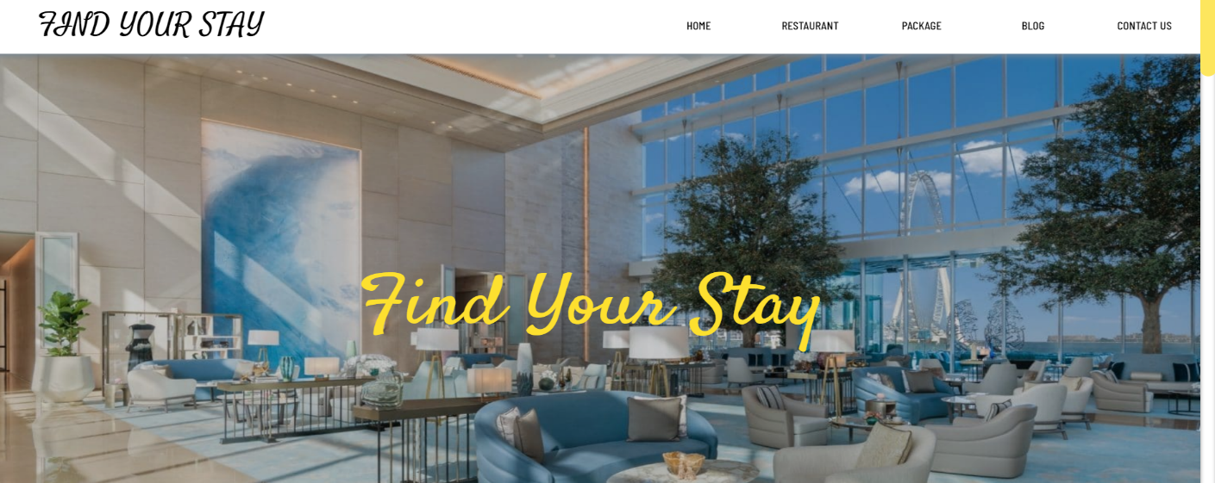

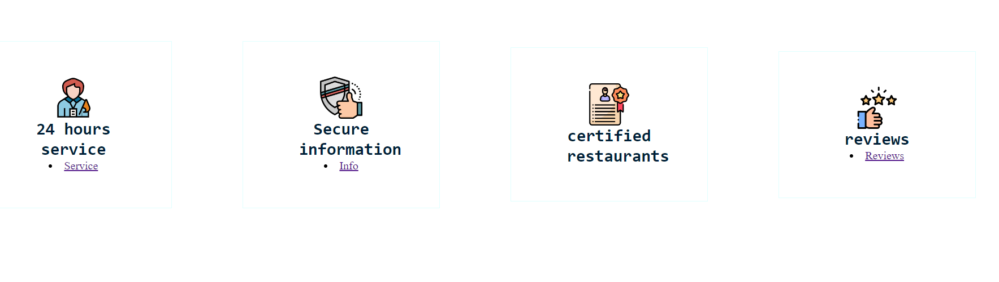

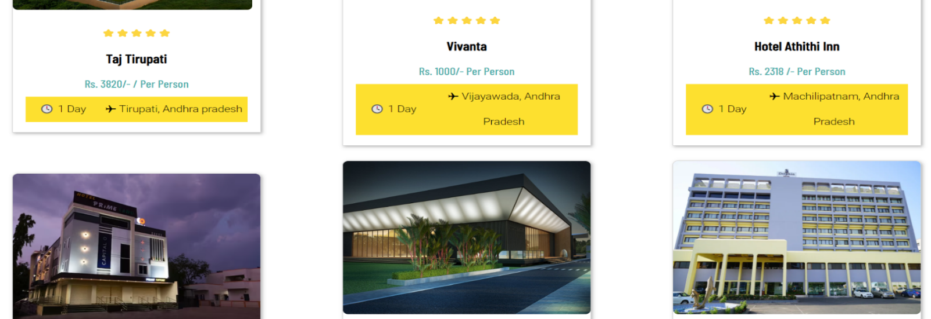

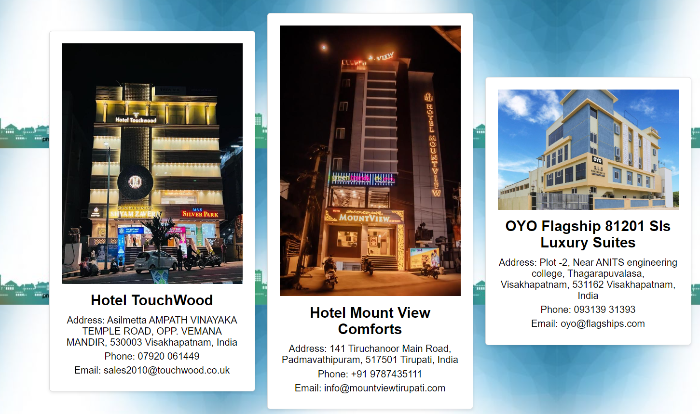

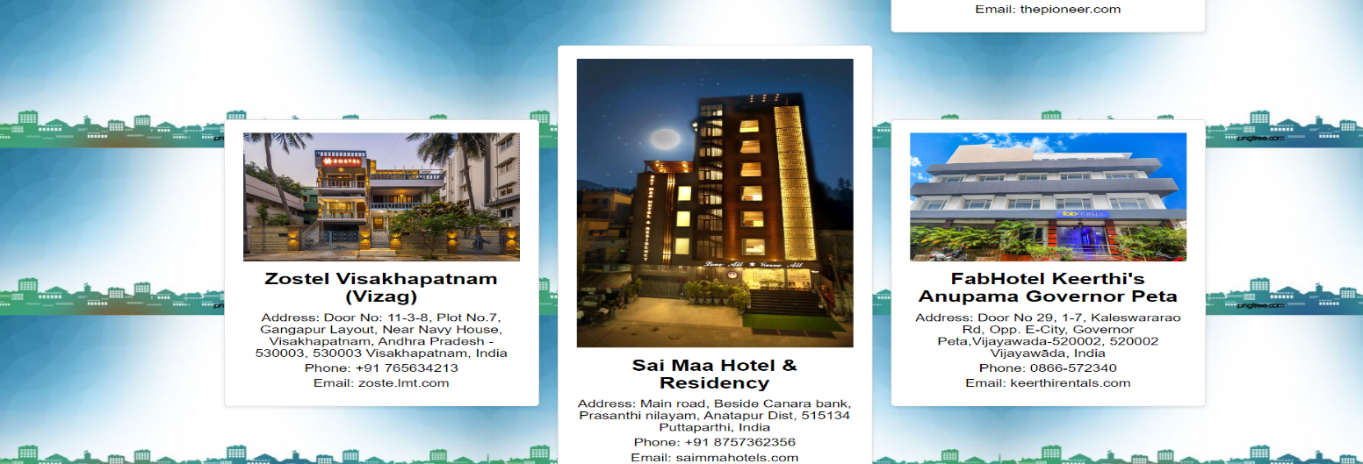

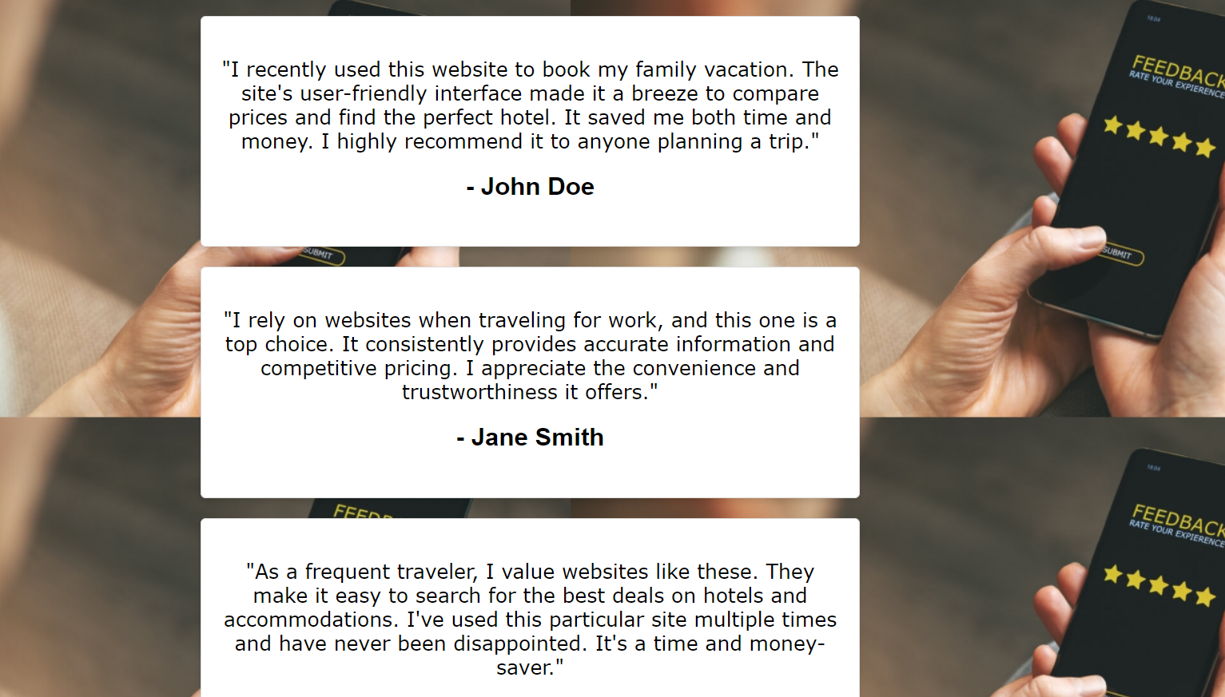

# **CONCLUSION**

In this project we have designed a website for “FIND YOUR STAY”. FIND YOUR STAY means a .

People usually think that carrying out a home decoration project can be a tedious, expensive, and time-consuming task. However, this may not always be true, especially when you can work on plenty of easy DIY arts and crafts projects to beautify your home interior with the help of some regular household items and common leftover materials. Moreover, you can also involve your kids when taking on such easy DIY home decor projects and even assign some easy tasks to them. This will not only keep your kids busy indoors but also let you spend some quality time with them.

Our Project contains information about the crafts. There are two categories Toys and Decoration you can also find the making process of them. The toys category includes Kondapalli toys, Clay toys, Hand knitted toys, Paper toys. It is fun, cost-effective, and interesting to make homemade toys for children as it helps them boost their creativity and imagination to make the desired toy.The decoration category includes the paper decorations etc. You find a find a video related to the craft and know the making process of that particular craft. The future scope of the project can be a commercial website where we can sell our products like some e-commerce website so that common people can buy the home made products easily .

People can easily make their crafts by visiting our website with the information provided. For one, home made products use less energy and fewer resources than their factory-made counterparts. In addition, homemade products are often made with love and care, which can result in less waste and less pollution. Besides the environmental benefits, buying homemade is also often more enjoyable.

**REFERENCES:**

* https://developer.mozilla.org/en-US/
* https://www.w3schools.com/html/html_images_background.asp
* https://www.geeksforgeeks.org/html-align-attribute/
* https://testbook.com/web-development
* https://www.codewithrandom.com/